Which of the following is used in oxidation of ketone?
A. $K_{2}Cr_{2}O_{7}/H_{2}SO_{4}$
B. $H_{2}SO_{4}$
C. $NaBH_{4}$
D. All of these
ANSWER: A

Oxidation of propanone gives
A. $HCOOH$
B. $CH_{3}COOH$
C. Both
D. None of these
Oxidation of 2-heptonone gives
A. $CH_{3}COOH$
B. $CH_{3}CH_{2}CH_{2}CH_{2}COOH$
C. $HCOOH$D. A and B
E. All of these
ANSWER: D
It cannot differentiate between benzaldehyde and acetone
A. Tollen’s reagent
B. Fehling solution
C. Benedict solution
D. All of these
ANSWER: B
Which of the following reagent is used to distinguish between aldehydes and ketone
A. Tollen’s reagent
B. Fehling solution
C. Benedict solution
D. All of these
ANSWER: D
It is also known as Brady’s reagent.
A. Sodum nitroprusside
B. Sodium bisulphite
C. 2,4-DNPH
D. None of these
ANSWER: C
It can be used as distinguishing test between carbonyl and non-carbonyl compound.
A. Sodum nitroprusside
B. Sodium bisulphite
C. 2,4-DNPH
D. None of these
ANSWER: C
Brick red ppt is formed in Fehling’s test with aldehyde.
A. Cupric tartrate
B. Cuprous oxide
C. Cupric oxide
D. Both B and C
ANSWER: B
Which of the following compound will form on reduction of aldehyde?
A. Primary alcohol
B. Secondary alcohol
C. Tertiary alcohol
D. All of these
ANSWER: A
Ketone reduction will give
A. Primary alcohol
B. Secondary alcohol
C. Tertiary alcohol
D. All of these
ANSWER: B
Which of the following catalyst is used in catalytic reduction?
A. Ni
B. Pt
C. Pd
D. All of these
ANSWER: D

Which of the following is used in reduction of aldehyde and ketone?
A. $K_{2}Cr_{2}O_{7}/H_{2}SO_{4}$
B. $H_{2}SO_{4}$
C. $NaBH_{4}$
D. All of these
ANSWER: C
Which of the following is mild oxidizing agent?
A. Fehling solution
B. Benedict solution
C. Tollen’s reagent
D. All of these
ANSWER: D
Which of the following can be oxidized by mild oxidizing agent?
A. Aldehyde
B. Ketone
C. Both
D. None of these
ANSWER: A
Which of the following compound will form on oxidation of aldehyde?
A. Alcohol
B. Carboxylic acid
C. Ester
D. All of these
ANSWER: B
The following reaction will produce
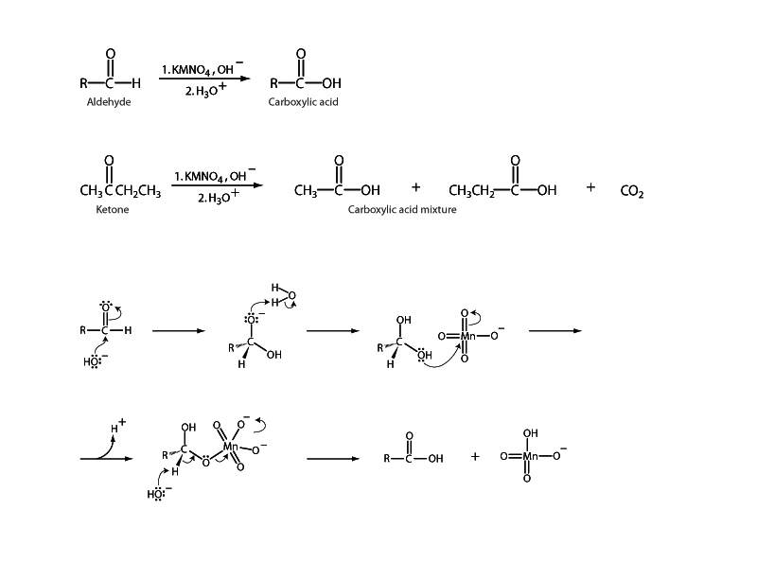
A. 
B. 
C. $CO_{2}$
D. 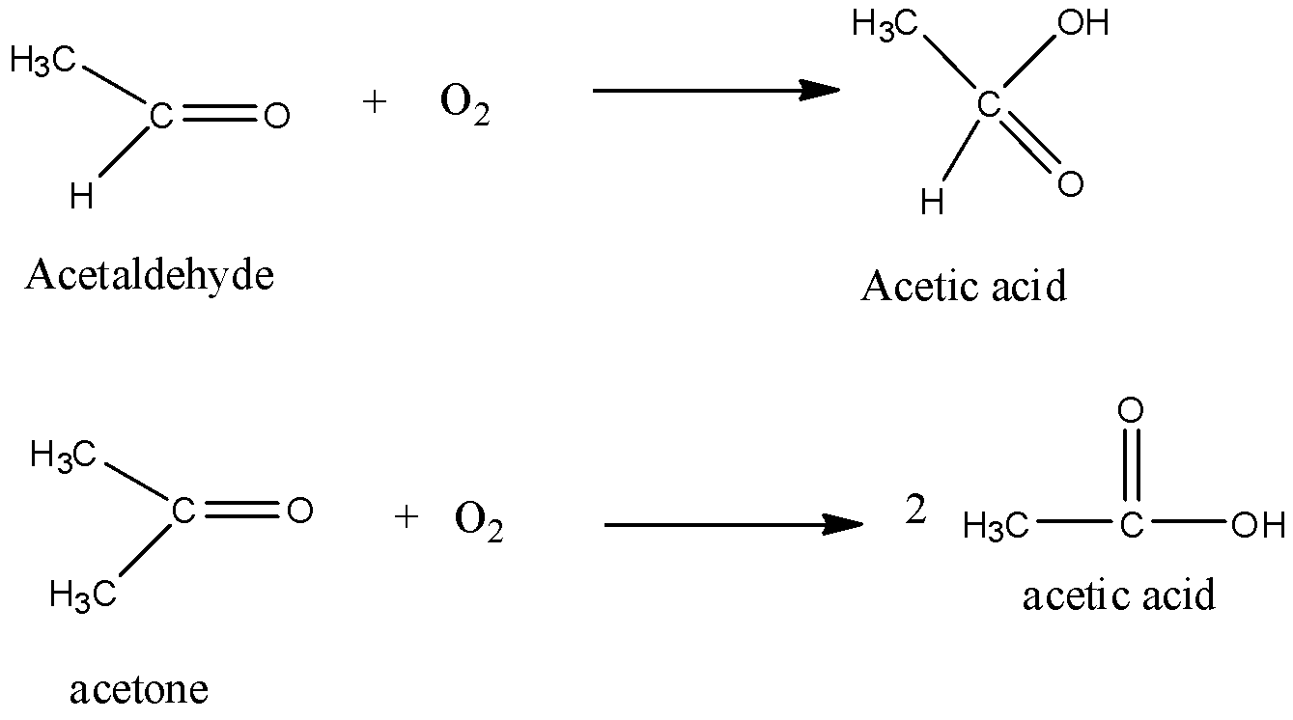
ANSWER: A

